GITLAB & IBM DEVELOPER FOR Z/OS

We use IBM developer for z/os to change jcl or codes, save it and commit to move it into gitlab repositories.
First setup is required to connect IBM developer to our mainframe for which we need HOST name. When setup is done then we login with our mainframe USER ID and PASSWORD.
At Left hand side you will see GITLAB repository (remote repository) which need to clone first, at Right hand side you will see mainframe pds (local repository)
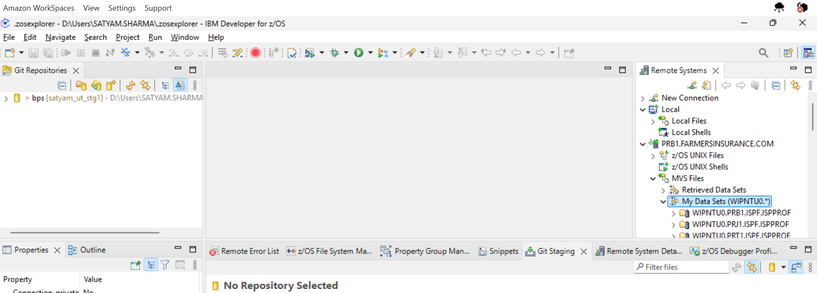
Inside MVS Files we get MY DATA SET -> Do right click on my data sets -> NEW -> FILTER

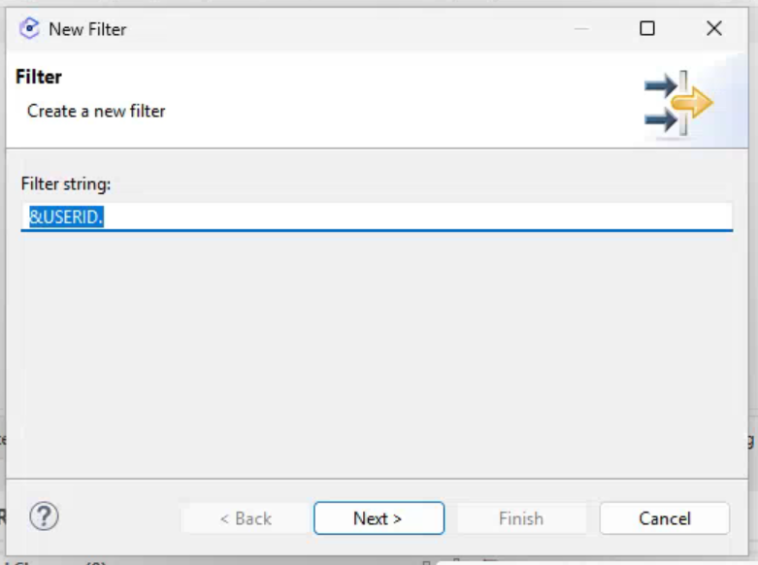
Give you mainframe USER ID i.e. WIPNTU0, you will get all the PDS present inside your user id wipntu0.*

Now we can simply click on the member’s name we want to edit and CTRL + S for save.
This SAVE will also reflect inside your mainframe as well.

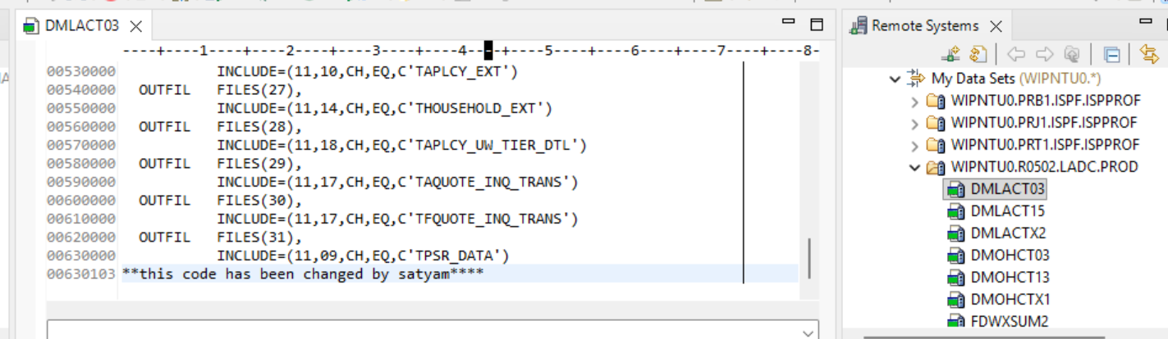

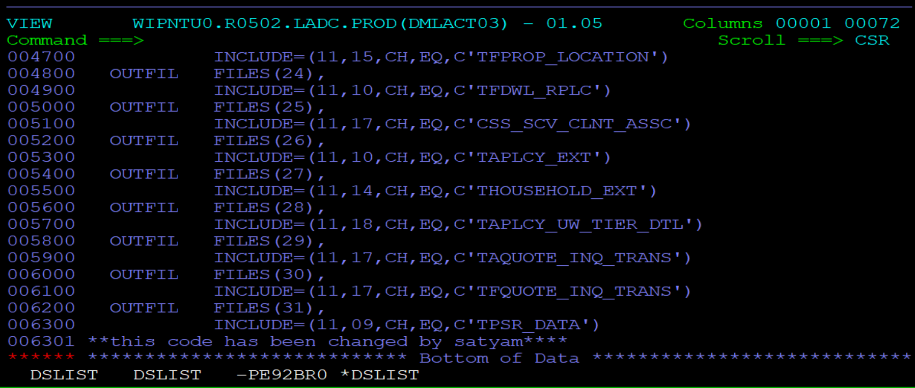
Now to move this change into production -> first goto your gitlab cloned repository which is at left hand side -> click on working tree ->
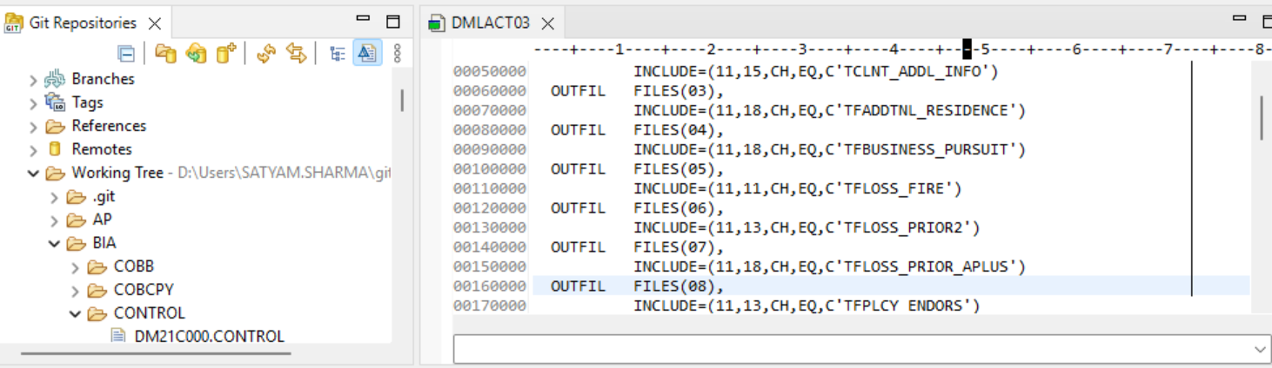
It is control card so dropdown on control -> set your cursor on any member name and type your member name DMLACT03 , you will get you member name.
Now double click on member name and open in editor
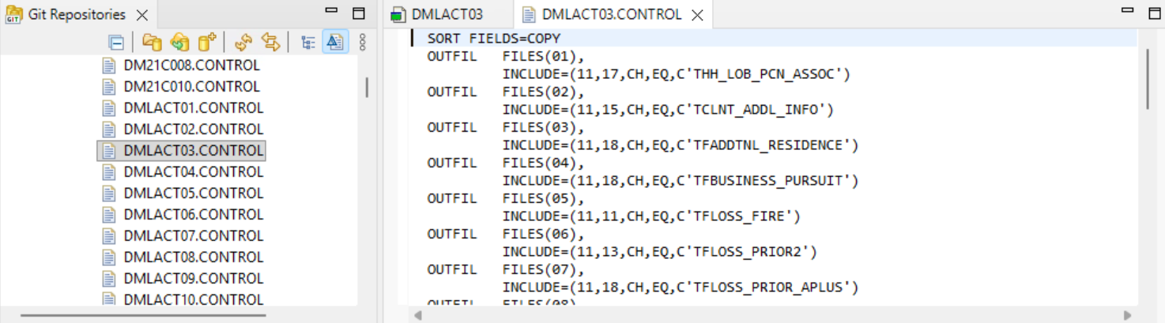
Now copy all the changed element (mainframe or local pds ) with Ctrl+A and paste (Ctrl+V) inside gitlab’s repository(remote) element, and save it Ctrl+S.
Now you will get one + sign with green highlighted box -> click on this green highlighted box and provide comment message “moving into gitlab” ->
Note:- Some time we don’t get that + sign then we need to goto File -> Refresh -> we will get this green highlighted box.
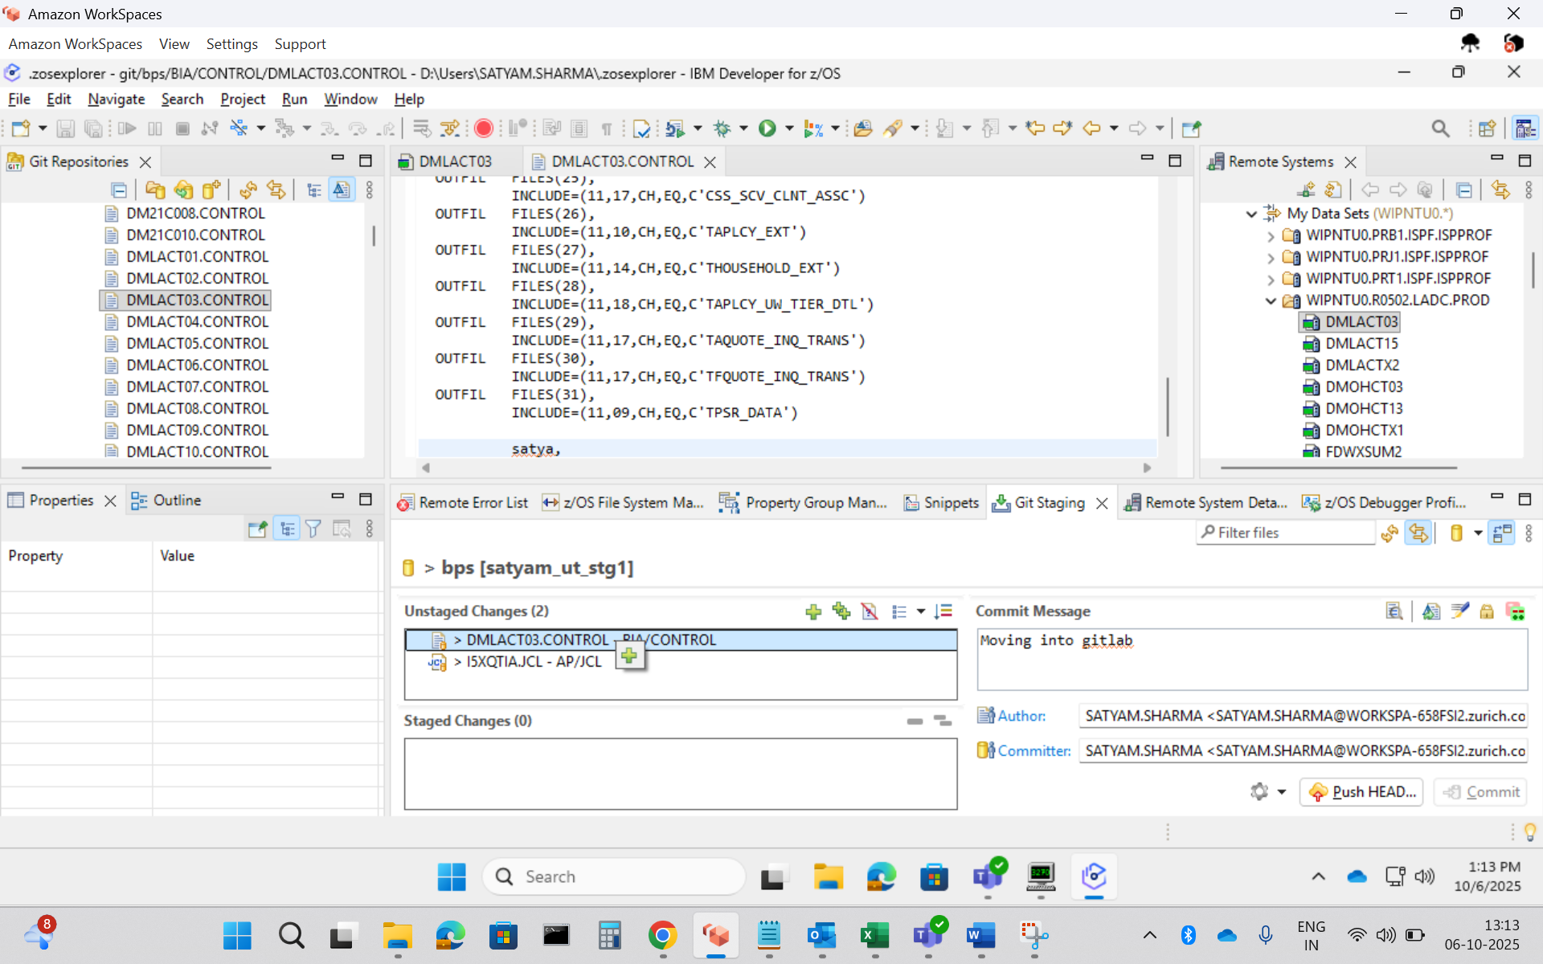
Now that element DMLACT03 will move to Staged changes from Unstaged changes, and click on COMMIT and PUSH
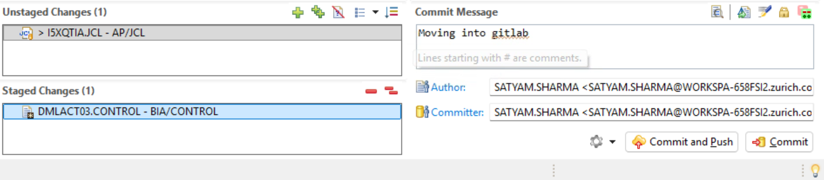

After that you will get one pushed notification like “ you have pushed element to branch ……….”
NOW OPEN GITLAB IN BROWSER :
You will get one notification like – satyam sharma just pushed one element into branch satyam-ut-stg1.
Now you need to move that element from satyam-ut-stg1 to ut-stg1 using change branch ‘source branch’- satyam-ut-stg1 and ‘target branch’ – ut-stg1, then click on compare branches and continue.
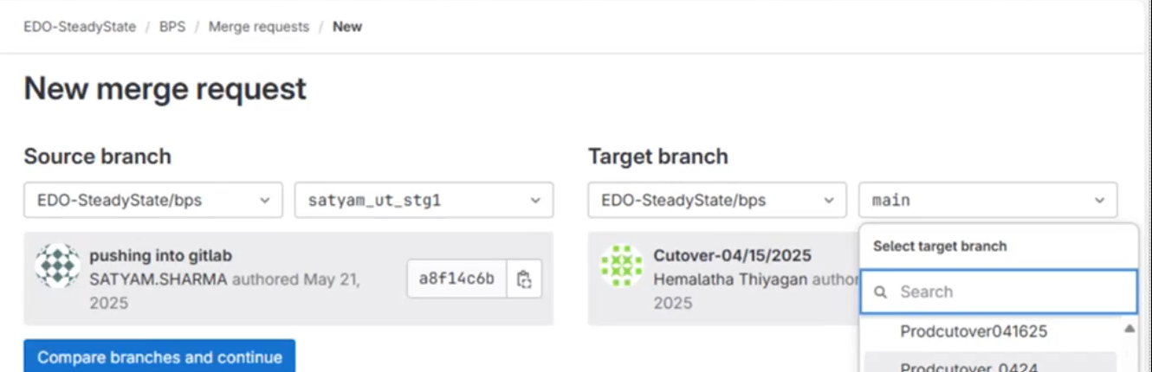
provide title something like ‘moving into ut-stg1’
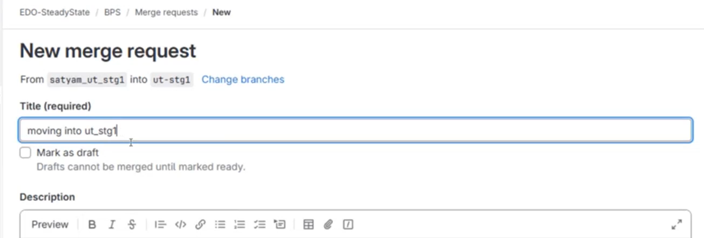
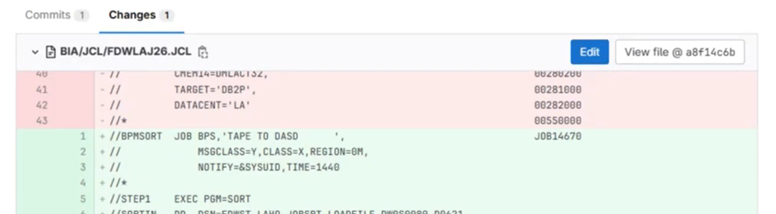

Green reflected code is newly added code and red reflected code is old code.
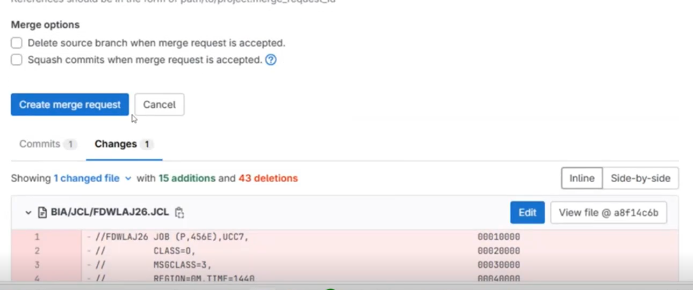
After verifying your changes -> click on create merge request.
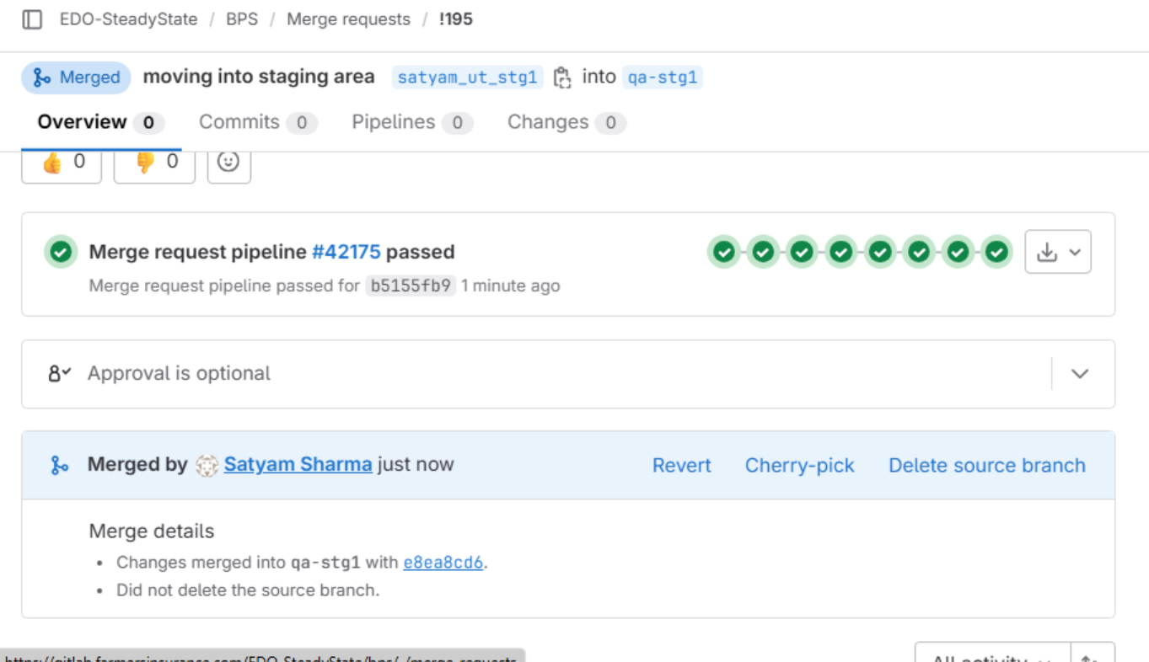
ut-stg1
If all are green means our code has passed pipeline successfully, code has been compiled.
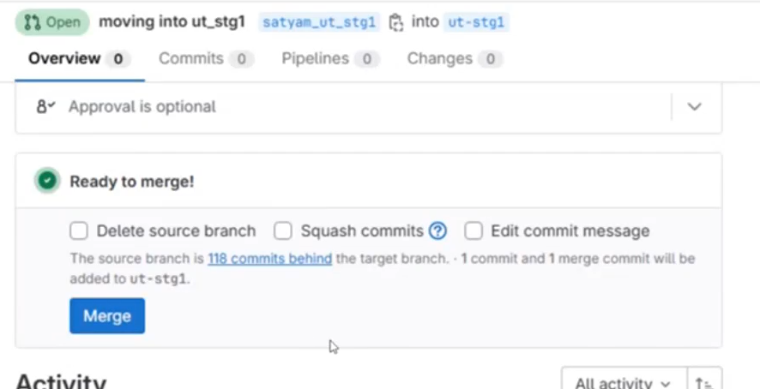
Click on merge.

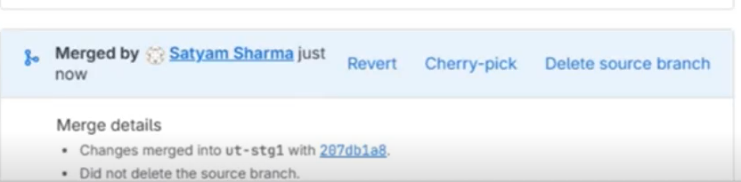

Merge competed into ut-stg1.

Same way we move our element till QA-STG2.
From QA-STG2 to PRODUCTION, gitlab team will take care of it.
To ACCESS GITLAB using IBM ZOS for pushing element we need to provide ACCESS TOKEN so that we don’t required to put password all the times

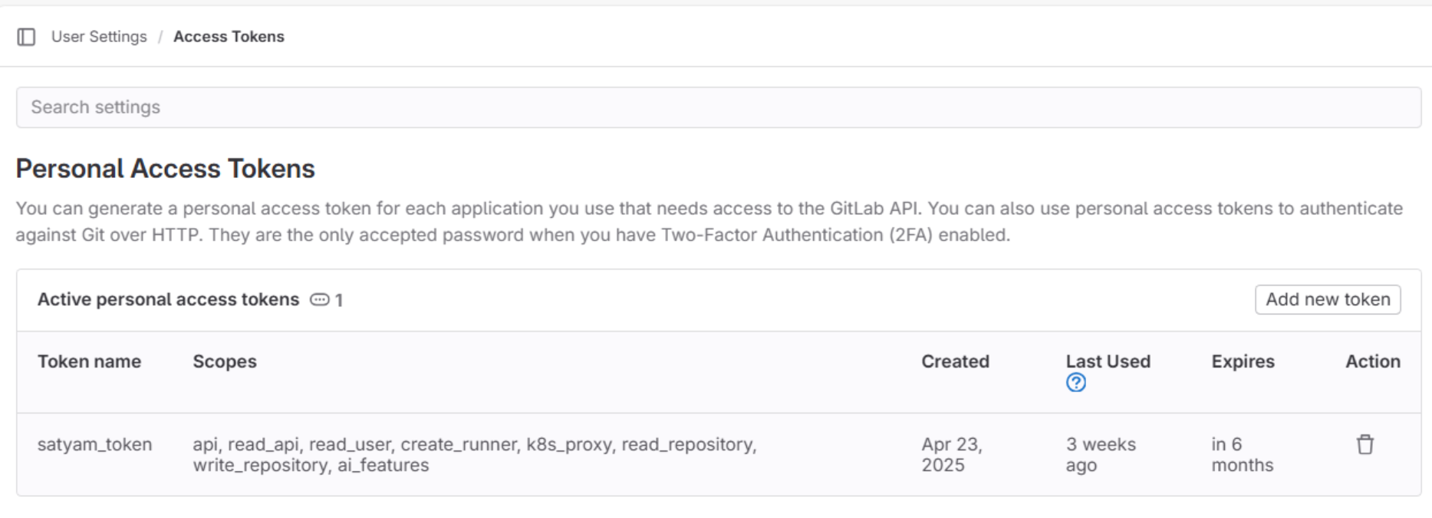
This token we need to provide in ibm developer for Z/OS.

